HR ATTENDANCE & WORKFORCE PRODUCTIVITY ANALYSIS

## PROJECT OVERVIEW
### An interactive HR Attendance Analysis Dashboard built in Microsoft Excel to monitor employee attendance, punctuality, workforce productivity, overtime and leave patterns across departments.
### The dashboard uses Pivot Tables, Pivot Charts, Slicers and KPI reporting to provide a clear view of workforce performance and help management identify areas requiring attention.s
---

## BUSINESS PROBLEMS
- Which departments have the highest number of present and leave records?
- Which departments experience higher late arrivals and early exits?
- Which departments have the highest overtime hours?
- How does workforce productivity vary across departments?
- Which leave types are used most frequently?
- How does attendance change overtime?
- Which departments require closer HR monitoring?
---
## TOOLS USED
- Microsoft Excel
- Pivot Tables
- Pivot Charts
- Slicers
- Conditional formatting

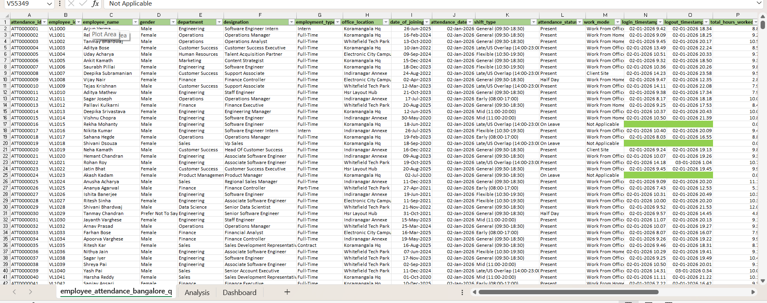
### DATASET OVERVIEW

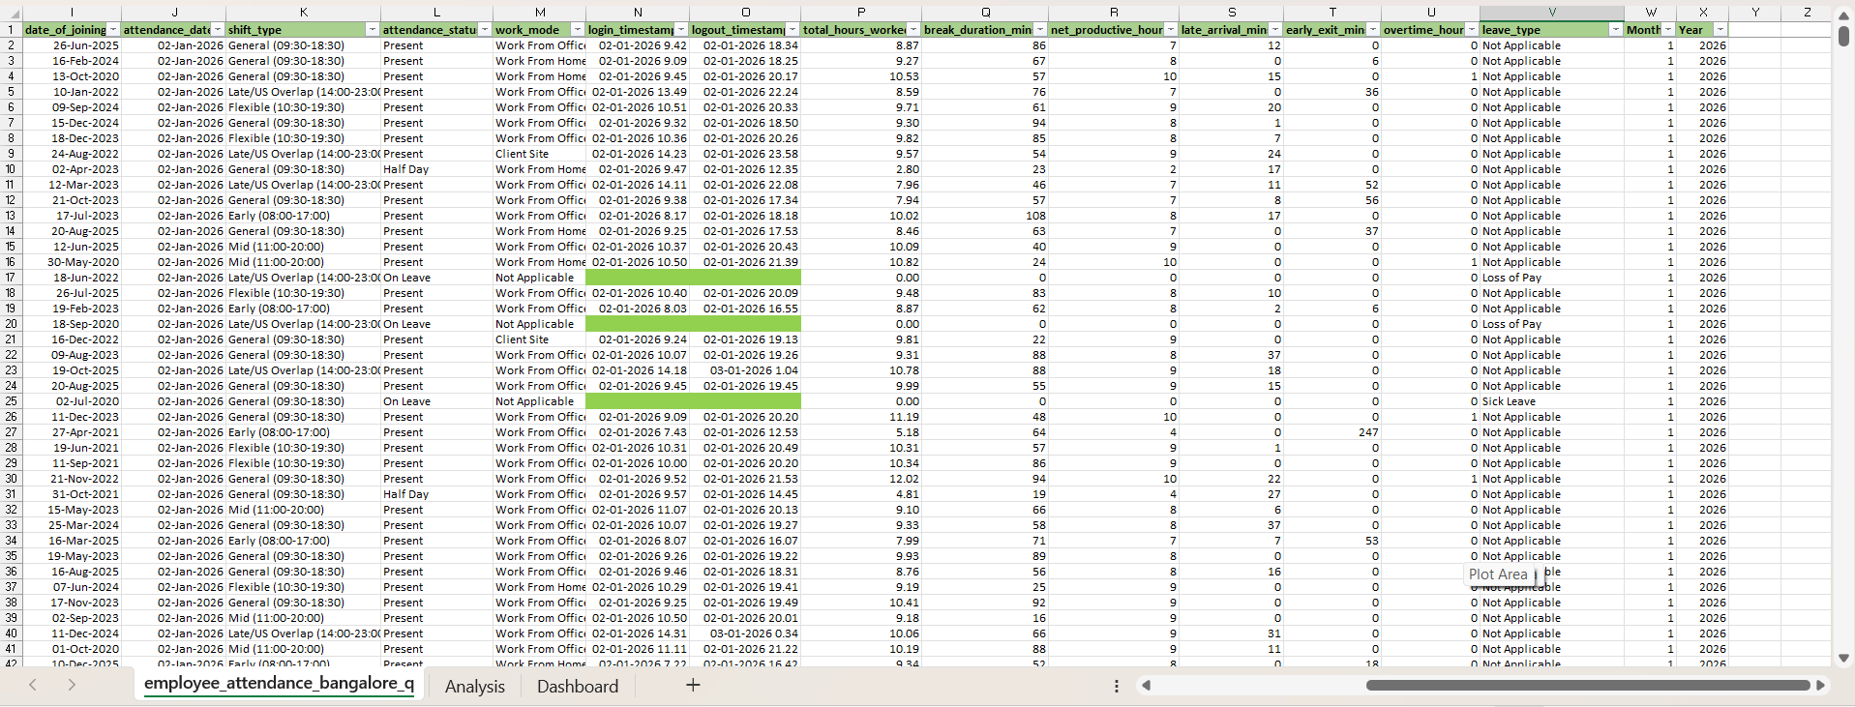

## KEY KPIs
- Total Employees
- Attendance Participation
- Present Days
- Leave Days
- Avg Productive hours
- Total Overtime
*Attendance Participation % is calculated using Present and Hald-Day records, while approved leave is excluded from the calculation.
---
## DASHBOARD ANALYSIS
### 1. Attendance Overview
- Department -wise Present, Half Day and On Leave records
- Comparison of attendance patterns across departments
### 2. Punctuality Analysis
- Avg late- arrival minutes by department
- Avg early-exit minutes by department
### 3. Monthly Attendance Trend
- Monthly Present, Hald- Day and On Leave records
- Identification of changes in attendance patterns
### 4. Productivity Analysis
- Avg total hours worked
- Avg of net productive hours
- Department-wise productivity comparison
### 5. Overtime Analysis
- Total overtime hours by department
- Identification of departments with higher overtime requirements
### 6. Leave Analysis
- Leave distribution by leave type
- Total leave days by department

### 7. Interactive Filters
- Attendance Year/ Month
- Department
- Work Mode
- Shift Type

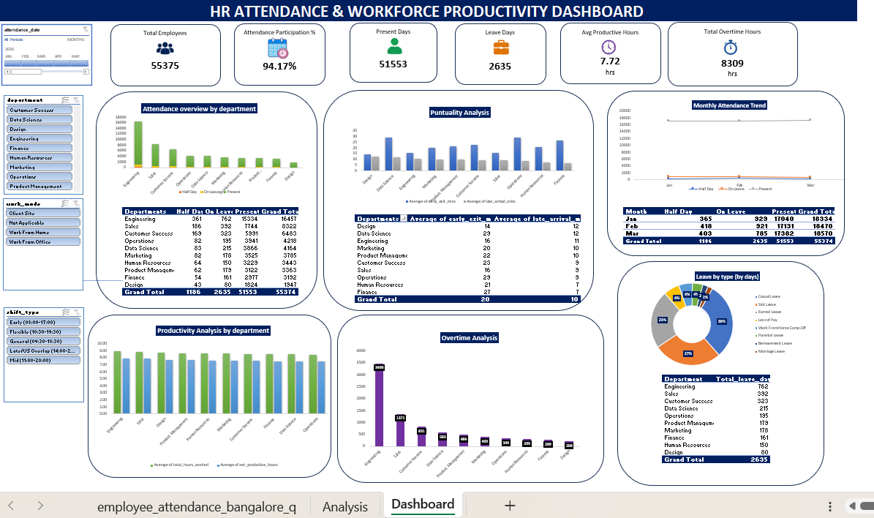

## KEY INSIGHTS
- Attendance participation is 94.17% excluding leave data, showing the most employees have regular attendance without absent in a single day.
- Engineering has the highest number of Present records 15334 and also the highest leave count 762 days with three months along with highest overtime 3490 hours much higher than other departments.
- Sales has the second-highest overtime 1371 hours, indicating a possible higher workload.
- Data Science and Operations show higher early-exit levels with average early exits of around 29 minutes.
- Design and Data Science have the highest average late-arrival times around 12 mins.
- Total recorder leave is 2635 days, with Engineering contributing the largest share.
- Employees work an average of 7.72 hours per day, providing a useful benchmark for workforce productivity.
---

## RECOMMENDATIONS
- Investigate the high overtime levels in Engineering and Sales to identify workload issues. Additionally provide some rewards or benefits for those employees who work overtime.
- Investigate repeated late arrivals and early exits in departments such as Data Science.
- Monitor leave patterns in Engineering and check whether workload is contributing to higher leave usage.
- Compare working hours and productive hours to identify where employees may be spending time without corresponding productive output.
- Use monthly attendance trends regularly to identify changes early and support better workforce planning.
- Investigate the reasons why employees don’t show punctuality to follow the timings.
---

## CONCLUSION
### The Attendance Analysis provides management with a consolidated view of employee attendance, punctuality, overtime and leave patterns to check workforce efficiency.
It helps to identify departments that require closer monitoring and supports better workforce planning and resource allocation.

